Research Map: School of Technology and School of Physical Sciences
Background
The Research Relations Team have mapped how research across the School of Technology and School of Physical Sciences maps onto funder themes and priorities. Focus is on EPSRC as the predominant research council of interest to the two Schools. As SPS & SoT research goes beyond EPSRC remit, we have also provided a map against all other Research Councils except AHRC and InnovateUK.
EPSRC Themes are:
- energy and decarbonisation
- engineering
- healthcare technologies
- information and communication technologies (ICT)
- manufacturing and circular economy
- mathematical sciences
- physical sciences & advanced materials
- quantum technologies

For each EPSRC Theme, we looked at:
- which areas have been identified by the funder as funding priorities
- which topics have recently been the focus of funding calls
- in which areas Cambridge has the most active awards
- how our activity in the Theme is spread across our groups and Departments.

Methodology
Size of Cambridge portfolio across each EPSRC Theme
Maps of the University of Cambridge grant portfolio in each EPSRC Theme were taken from EPSRC’s publicly available tool Visualising Our Portfolio. This provides a snapshot of grants awarded via JeS that were live on 30/11/2024. This tool does not include grants made through the new TfS system, and so whilst it provides a relatively recent picture, it will become less useful over time.
Activity in each EPSRC Theme across Departments
We used Google’s AI Large Language Model NotebookLM to produce a table for each department listing groupings, alignment with EPSRC Research Areas, research activity, key academics (PIs only) and research centres within Cambridge. Source material included in this data-scrape included relevant Cambridge UoA Environment Statements from REF2021, departmental research webpages and information on EPSRC’s Themes and research areas available on their website. Using this information we then assigned each departmental group to one or more EPSRC Themes.
- The AI’s assignment of academics to research areas was unreliable, so this field was corrected manually.
- “Groupings” vary across departments: some departments group into broad themes/areas of research, whilst others are more granular at the level of one or two PIs. Therefore, in some Departments a PI may be in multiple groupings, and in others each PI is in only one.
- Each member of staff may be listed against multiple EPSRC Themes.
Tree maps were then generated using Flourish data visualisation tool (https://app.flourish.studio/). Maps display departments and groupings active in that Theme. The size of each box is determined by the number of academic staff it represents.
Each map below is a clickable link to a dynamic map online, which allows you to click through to the following levels: department, grouping, summary, people (Faculty).

All Themes
Visualising our Portfolio map of University of Cambridge Grant portfolio, by EPSRC Themes and Research Areas. NB Research Areas ‘other’ and ‘out of EPSRC remit’ have been removed.
‘Ctrl + Click’ image to view interactive map online
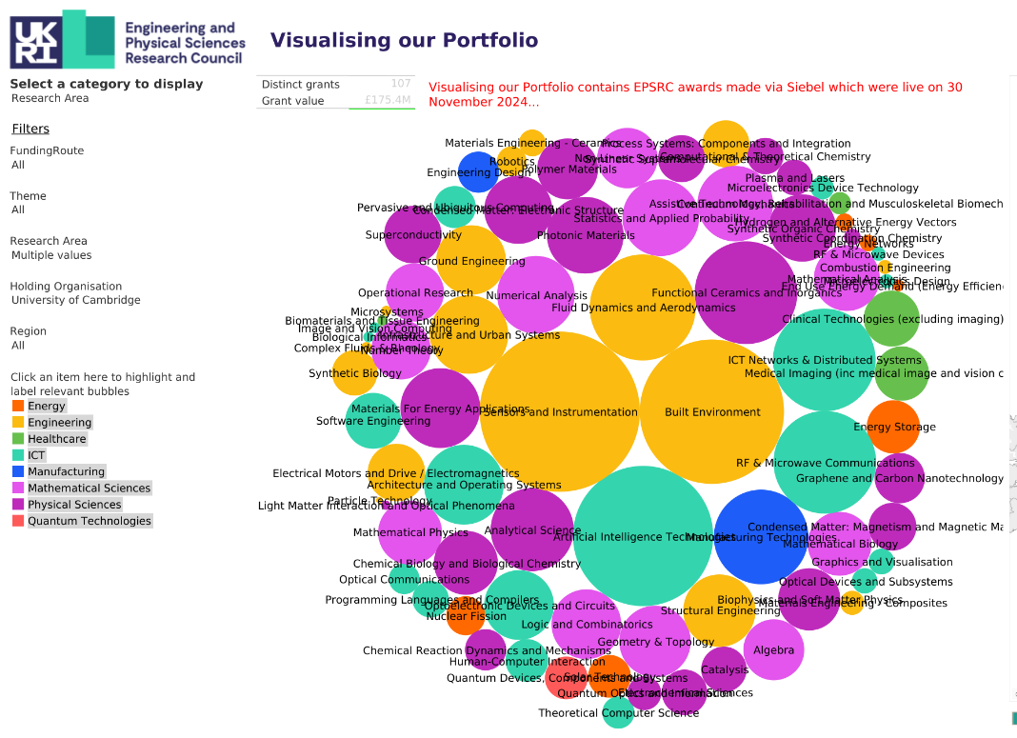
https://public.tableau.com/shared/RFMT58GGG

Flourish ‘Tree map’ of activity in each EPSRC Theme by department
‘Ctrl + Click’ image to view interactive map online
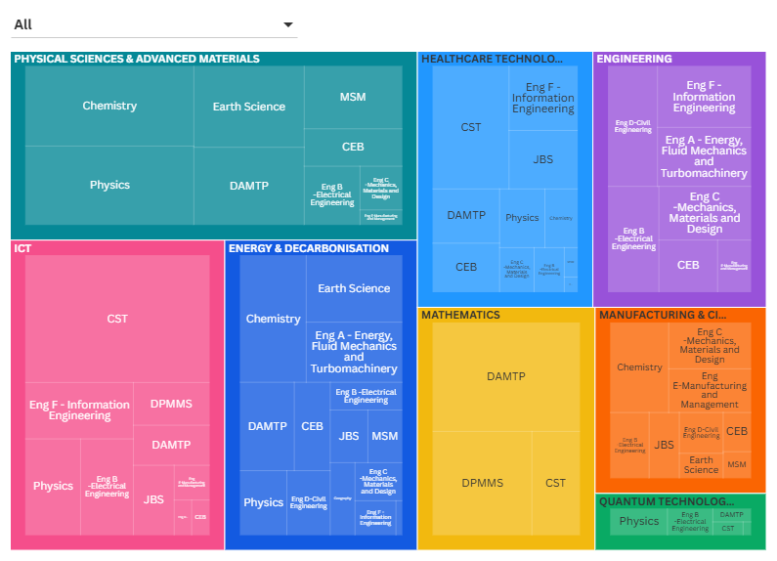https://public.flourish.studio/visualisation/22396569/

Energy and Decarbonisation
https://www.ukri.org/what-we-do/browse-our-areas-of-investment-and-support/energy-theme/
Summary
Research areas covered by the energy and decarbonisation theme include:
• bioenergy
• carbon capture and storage
• end use energy demand (energy efficiency)
• energy networks
• fuel cell technology
• hydrogen and alternative energy vectors
• marine wave and tidal
• nuclear fission
• solar technology
• wind power
• whole energy systems

Funding opportunities over the last 5 years have focussed on renewable energy, offshore renewable energy, clean energy, energy storage, interseasonal energy storage (IES), nuclear energy, marine wave energy, bioenergy, hydrogen, systems approaches to net zero, digital solutions to reduce energy demand and carbon production, digitally enabled circular economy and sustainable digital technologies, digital twinning for decarbonising transport, recycling technologies, sustainable technologies and operations, circular materials, nanomaterials, advanced materials for sustainability, sustainable computing, sustainable industries, just energy transitions in developing countries, green economy.
Visualising our Portfolio map of University of Cambridge Grant portfolio in Energy & Decarbonisation, by EPSRC Research Area
https://public.tableau.com/shared/SBJTCFNPW

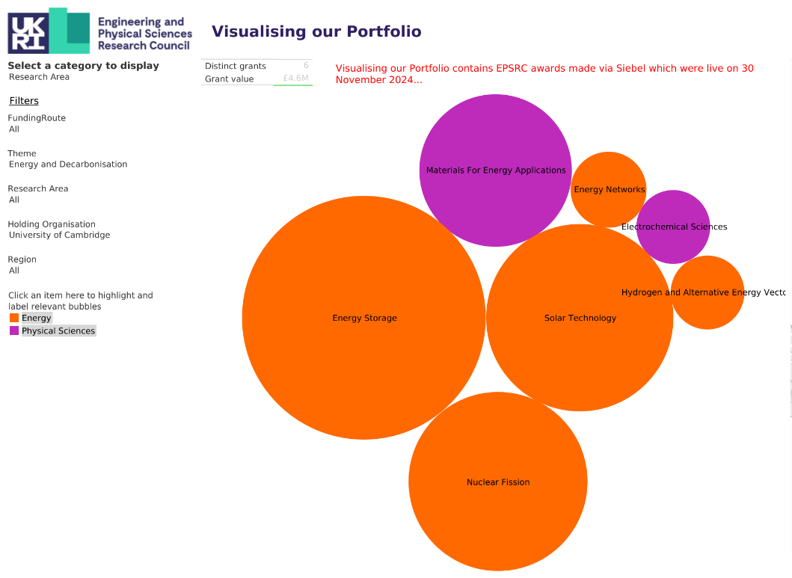

Flourish ‘Tree map’ of department groupings in Energy & Decarbonisation
https://public.flourish.studio/visualisation/22283600/
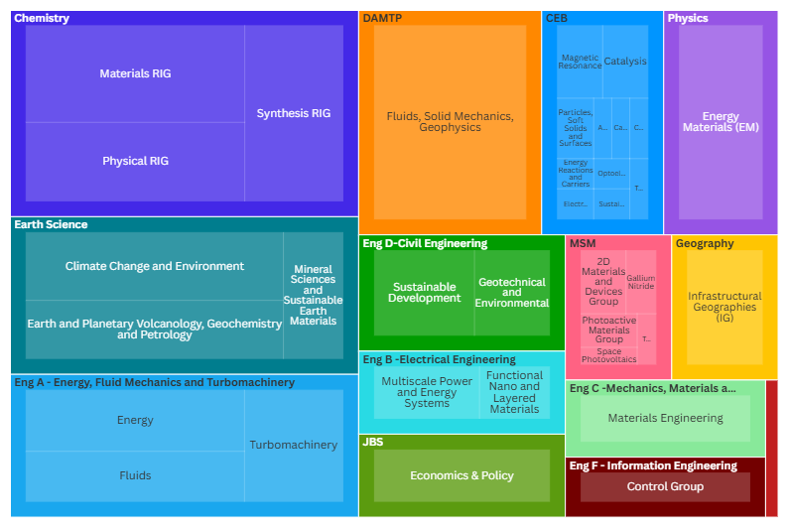

Research centres in Cambridge:
- Energy IRC
- Henry Royce Institute for Advanced Materials
- Winton Programme for the Physics of Sustainability
- Cambridge Centre for Advanced Research and Education (CARES)
- Centre of Advanced Materials for Integrated Energy Systems (CAM-IES)
- Cambridge Centre for Environment, Energy and Natural Resource Governance (C-EENRG) (Land economy)
- Faraday Institution
- Centre for Sustainable Road Freight (SRF)
- Whittle Lab
- Resource Efficiency Collective
- Cambridge Circular Plastics Centre
- Cambridge Centre for Industrial Sustainability
- Nano Manufacturing group
- Energy Efficient Cities initiative
- Cambridge Centre for Smart Infrastructure and Construction
- Cambridge Nuclear Energy Centre
- Institute for Energy and Environmental Flows
- Energy Policy Research Group
- Cambridge Zero
- Cambridge Institute for Sustainability Leadership (CISL)
Engineering
https://www.ukri.org/what-we-do/browse-our-areas-of-investment-and-support/engineering-theme/
Summary
Tomorrow’s Engineering Research Challenges report identifies 7 cross cutting themes and 8 technical challenges:
Cross-Cutting Themes
- Achieving net zero and sustainability
- Faster digital design
- Greater access and use of data
- Increasing human resilience
- Understanding complex systems
- Harnessing disruptive, emerging technologies
- Underpinning tools and techniques
Technological Challenges
- Space
- Transportation Systems
- Materials
- Health and Wellbeing
- Robotics and AI
- Responsible Engineering
- Nature-Based Engineering
- Global Engineering Solutions
Funding opportunities over the last 5 years have focussed on telecommunications, future communications systems, semiconductors, terahertz technologies and systems, autonomous robotic systems for national security and defence, engineering healthier environments, engineering biology, AI for engineering, healthcare technologies, sustainable technologies, digital twinning (for crisis resilience/decarbonising transport), systems approaches to net zero, novel sensing for UK defence and security, renewable energy technologies, net zero transport, fluid dynamics.

Visualising our Portfolio map of University of Cambridge Grant portfolio in Engineering by EPSRC Research Area
https://public.tableau.com/shared/9WTWKHXX9
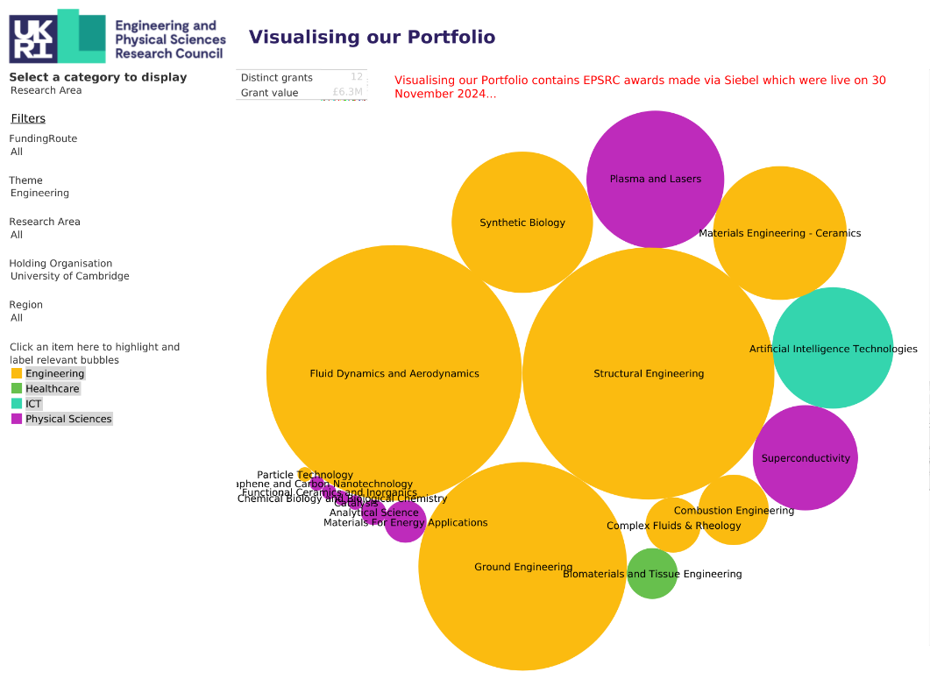
Flourish ‘Tree map’ of department groupings in Engineering
https://public.flourish.studio/visualisation/22317661/
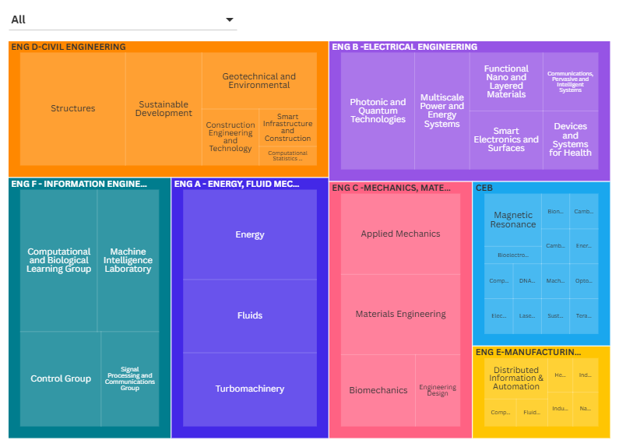
Research centres in Cambridge:
- Whittle Laboratory- National Centre for Propulsion and Power
- CDT in Future Propulsion and Power
- Centre for Doctoral Training in Photonic and Electronic Systems
- Centre for Photonic Systems
- Centre for Photonic Devices and Sensors
- TITAN Platform
- Centre for Climate Repair at Cambridge
- Centre for Engineering Better Care
- Engineering Design Centre
- Cambridge Centre for Smart Infrastructure and Construction
- National Research Facility for Infrastructure Sensing
- EPSRC Centre for Doctoral Training in Future Infrastructure and Built Environment
- Centre for Sustainable Development
- The Laing O'Rourke Centre for Construction Engineering and Technology
- Digital Roads for the Future
- Inkjet Research Centre
- Magnetic Resonance Research Centre (MRRC)
- Cambridge Graphene Centre
- UCI Policy Evidence Unit
- Centre for Doctoral Training in Ultra Precision Engineering
- EPSRC Centre for Innovative Manufacturing in Ultra Precision
- The Nanoscience Centre

Healthcare Technologies
https://www.ukri.org/what-we-do/browse-our-areas-of-investment-and-support/healthcare-technologies-theme/
Summary
Priority areas for the Healthcare Technologies Theme include:
- improving population health and prevention
- transforming prediction and early diagnosis
- discovering and accelerating the development of new interventions
Funding opportunities over the last 5 years have focussed on transformative healthcare technologies, translational partnerships, transforming prediction and early diagnosis in the community, transforming care and health at home and enabling independence, enabling independence for people living with dementia, respiratory health diagnosis, asthma health, mental health, engineering healthier environments, climate change and health, health co-benefits of the transition to net zero, infectious disease resilience, vaccines manufacturing, accelerating the development of future medicines, artificial intelligence innovation to accelerate health research, human centred decision making through data visualisation, digital health, digital technologies for health and care, engineering biology for advanced therapies, responsible neurotechnology research, technological innovation for understanding cancers of unmet need.
Visualising our Portfolio map of University of Cambridge Grant portfolio in Healthcare Technologies, by EPSRC Research Area
https://public.tableau.com/shared/BQXS6C588
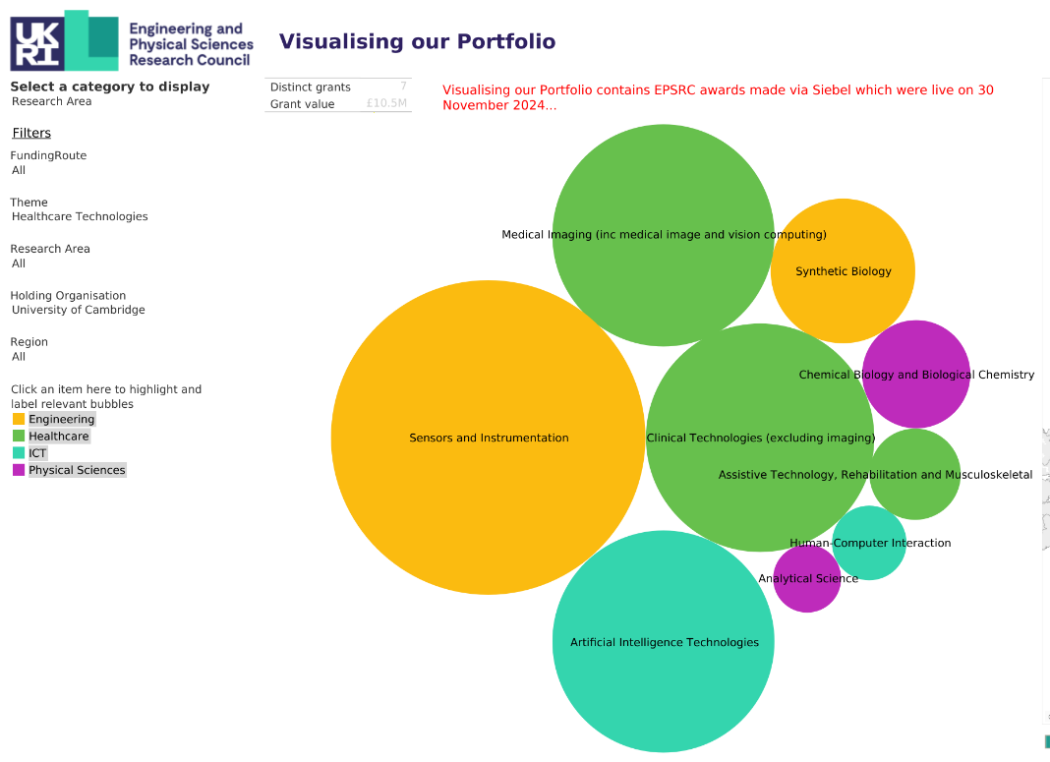

Flourish ‘Tree map’ of department groupings in Healthcare Technologies
https://public.flourish.studio/visualisation/22282623/

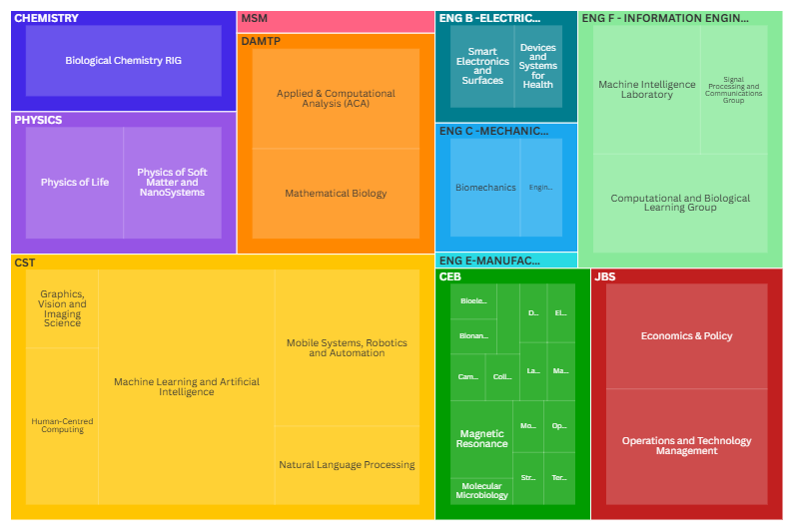

Research centres in Cambridge:
- Centre for Misfolding Diseases (CMD)
- Chemistry of Health Incubator
- Centre for Physical Biology
- Cardiovascular IRC
- Precision Health IRC
- Engineering Biology IRC
- Centre for Mobile Wearable Systems and Augmented Intelligence
- Centre for Engineering Better Care
- Engineering Design Centre
- Magnetic Resonance Research Centre (MRRC)
- Cambridge Centre for Neuropsychiatric Research
- The Cambridge Mathematics of Information in Healthcare Hub
- Cambridge Centre for AI in Medicine
- The Nanoscience Centre

Information and communication technologies (ICT)
https://www.ukri.org/what-we-do/browse-our-areas-of-investment-and-support/information-and-communication-technologies-theme/
Summary
The ICT Theme have four cross-cutting priorities:
- Next Generation Computing
- Sustainable ICT and ICT for sustainability
- Semiconductor Technology
- Future Communications
Funding opportunities over the last 5 years have focussed on artificial intelligence, research software engineering, human-centred AI, metascience AI, high end computing, future internet, future communications systems, AI decision support /novel computing for national security and defence, neuromorphic computing, cybersecurity, semiconductor technologies with relevance to ICT devices, exascale software, quantum software and algorithms, human centred decision making through data visualisation, resilient solutions for future UK systems, digital economy, equitable digital societies, protecting citizens online, trustworthy autonomous systems.

Visualising our Portfolio map of University of Cambridge Grant portfolio in ICT by EPSRC Research Area
https://public.tableau.com/shared/SQP5DK47Q
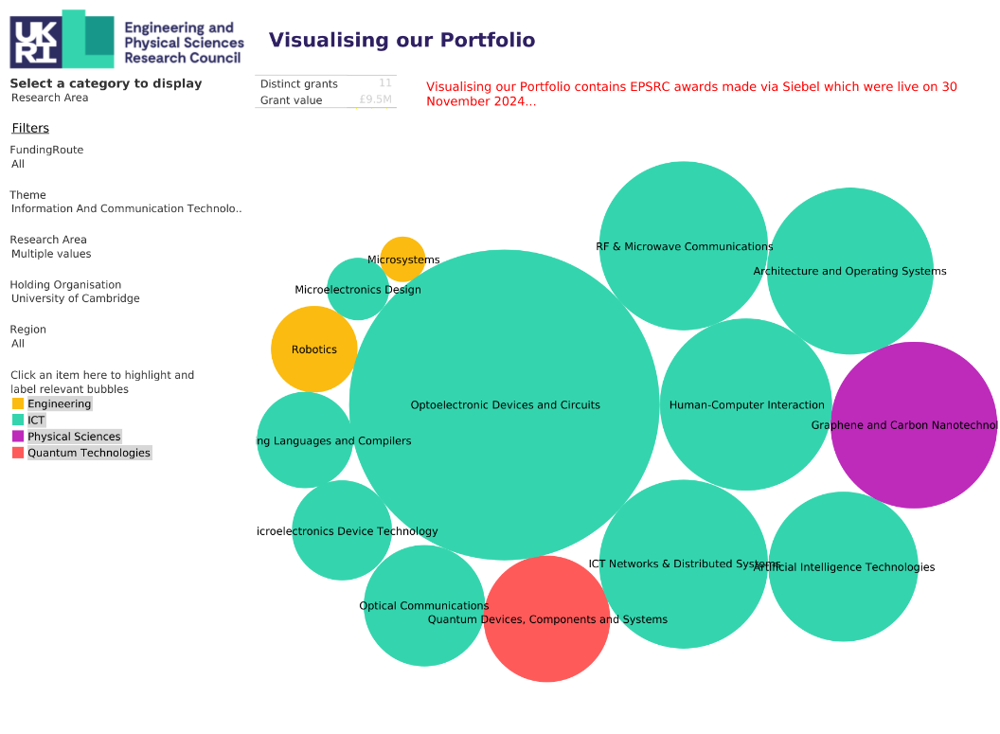

Flourish ‘Tree map’ of department groupings in ICT
https://public.flourish.studio/visualisation/22318376/
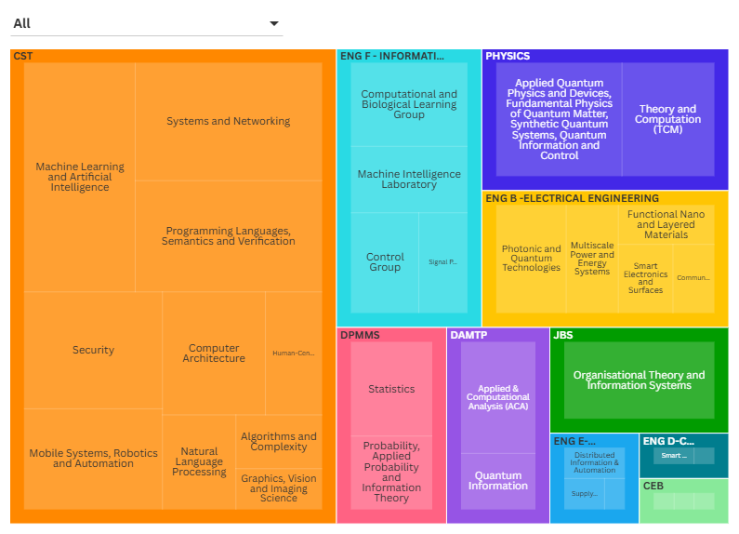
Research centres in Cambridge:
- CASCADE Computer Architecture & Semiconductor Design Centre
- Centre for Doctoral Training (CDT) in the Application of Artificial Intelligence to the study of Environmental Risks (AI4ER)
- Centre for Mobile Wearable Systems and Augmented Intelligence
- Cambridge Language Sciences IRC
- Cambridge Cybercrime Centre
- Microsoft Cloud Computing Research Centre
- Centre for Smart Infrastructure and Construction
- Laboratory for Scientific Computing (LSC)
- Centre for Scientific Computing (CSC)
- Institute of Computing for Climate Science

Manufacturing & Circular Economy
https://www.ukri.org/what-we-do/browse-our-areas-of-investment-and-support/manufacturing-and-the-circular-economy-theme/
Summary
Priorities for the Manufacturing and the circular economy theme include:
- Manufacture the next generation
- Advancing recycling capability
- Materials for a sustainable future
- Realising the transformational impact of digital technologies
- Maximising value from existing resources and systems
- Embed design for sustainability and drive a systems approach
Funding opportunities over the last 5 years have focussed on recycling capabilities, sustainable industries, manufacturing for sustainable futures, circular materials, next generation manufacturing technologies, digitally enabled circular economy, adventurous manufacturing, modelling UK supply chains, plastics circular economy, vaccines manufacturing, digital manufacturing, new manufacturing instrumentation, interdisciplinary circular economy, precision manufacturing, systems approaches to net zero.

Visualising our Portfolio map of University of Cambridge Grant portfolio in Manufacturing & Circular Economy by EPSRC Research Area
https://public.tableau.com/shared/K5TJPW6WX
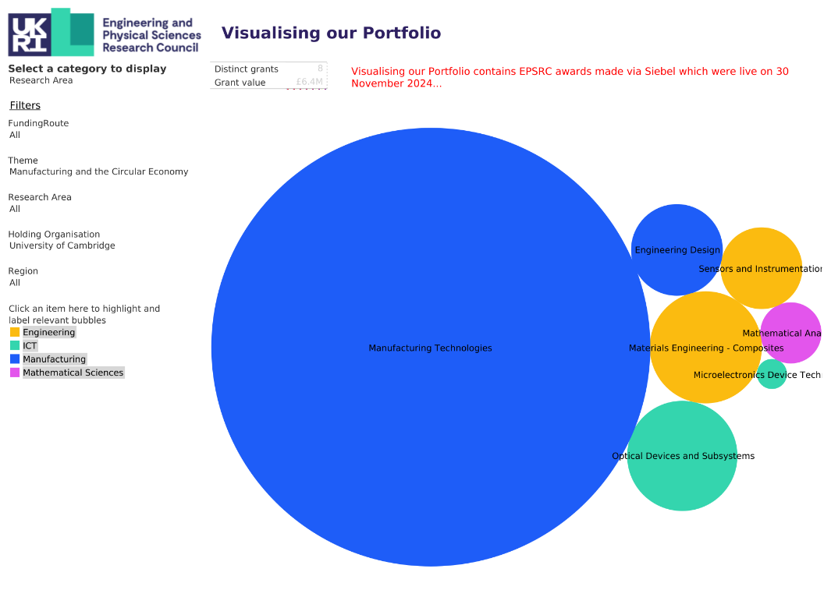

Flourish ‘Tree map’ of department groupings in Manufacturing & Circular Economy
https://public.flourish.studio/visualisation/22322467/
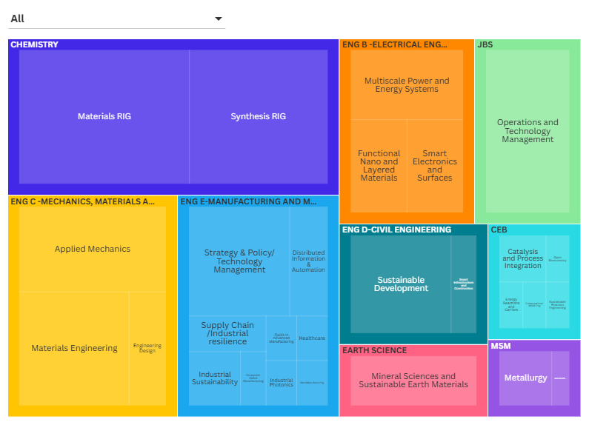
Research centres in Cambridge:
- Cambridge Circular Plastics Centre
- Cambridge Graphene Centre
- Yusuf Hamied Laboratory for Chemical Synthesis & Catalysis
- Rolls-Royce University Technology Centre
- iDMT - Innovation Centre in Digital Molecular Technologies
- IfM – Institute for Manufacturing
- IfM Engage
- Centre for International Manufacturing
- Centre for Industrial Photonics (CIP)
- EPSRC Centre for Doctoral Training in Ultra Precision Engineering
- Circular Economy Centre (CEC)
- UK FIRES

Mathematical Sciences
https://www.ukri.org/what-we-do/browse-our-areas-of-investment-and-support/mathematical-sciences-theme/
Summary
Mathematical Sciences covers pure mathematics, applied mathematics, Mathematical Physics, Geometry & Topology, Continuum Mechanics, Logic & Combinatorics, Number Theory, Mathematical Biology, Algebra, Statistics & Applied Probability, Operational research, Analyses, non-linear systems
Priorities include:
- Fundamental research driving discovery, the economy, and innovation: with Mathematical Sciences are at the cutting-edge of human endeavour
- The UK needs deep analytical thinkers: Mathematics, data science, and statistics are increasingly influential in our daily lives
- Mathematical Sciences needs to be embedded throughout academia, industry and government: Mathematical and statistical models are critical in understanding, anticipating, and intervening in complex areas of policy and decision making
Funding opportunities over the last 5 years have focussed on fellowships, small grants, programme grants. Recent topics include: Mathematical modelling for next gen formulated products, mathematical and computational foundations of artificial intelligence, AI decision support for national security and defence, Artificial intelligence for real data and for scientific and engineering research, quantum computing, quantum technologies, modelling infectious diseases.
Visualising our Portfolio map of University of Cambridge Grant portfolio in Mathematical Sciences by EPSRC Research Area
https://public.tableau.com/shared/Y2F8QDW4S
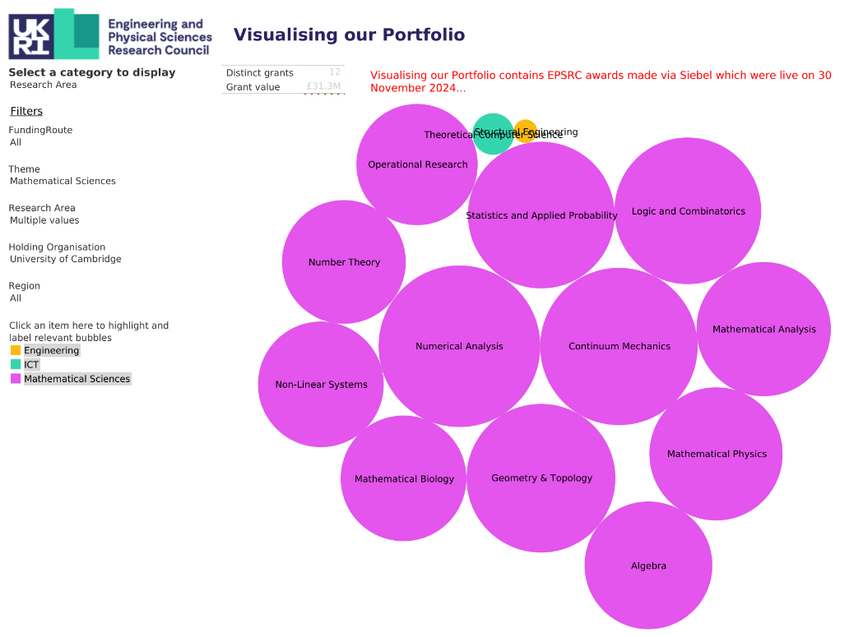
Flourish ‘Tree map’ of department groupings in Mathematical Sciences
https://public.flourish.studio/visualisation/22322894/
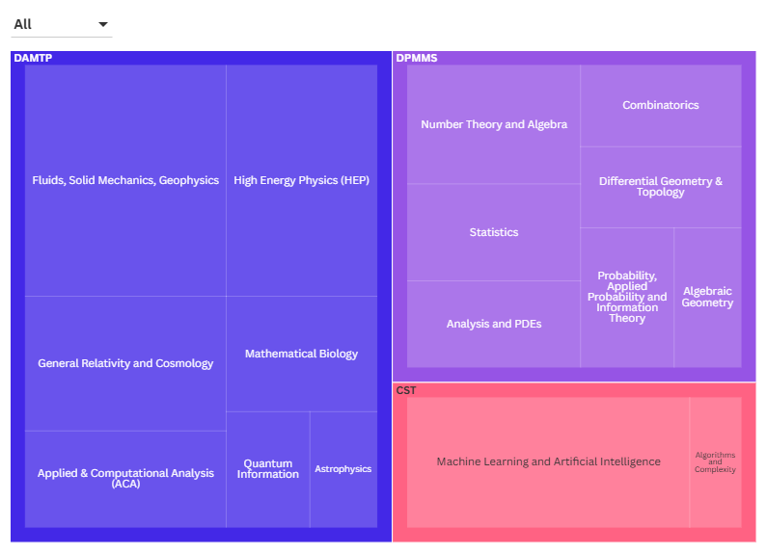
Research centres in Cambridge:
- AI4ER (CDT)
- Cantab Capital Institute for the Mathematics of Information
- Cambridge Centre for Analysis (CDT)
- Cambridge Centre for AI in Medicine (CCAIM)
- Centre for Quantum Information and Foundations
- Cambridge Centre for Theoretical Cosmology (CTC)
- Cambridge Mathematics of Information in Healthcare
- Cambridge Mathematics of Information (CDT)

Physical Sciences & Advanced Materials
https://www.ukri.org/what-we-do/browse-our-areas-of-investment-and-support/physical-sciences-theme/
https://www.ukri.org/what-we-do/browse-our-areas-of-investment-and-support/advanced-materials-theme/
Summary
Priorities for the Physical Sciences and Advanced Materials have included:
- Chemical sciences and engineering grand challenges (e.g. artificial intelligence and machine learning (AI/ML) within the content of the chemical sciences)
- Emergence and physics far from equilibrium
- Quantum physics for new quantum technologies
- Nanoscale design of functional materials
- Understanding the physics of life
The key EPSRC research areas for advanced materials are:
- biomaterials and tissue engineering
- condensed matter: electronic structure
- condensed matter: magnetism and magnetic materials
- functional ceramics and inorganics
- graphene and carbon nanotechnology
- materials engineering: ceramics
- materials engineering: composites
- materials engineering: metals and alloys
- materials for energy applications
- photonic materials
- polymer materials
- superconductivity
- spintronics
Funding opportunities over the last 5 years have focussed on advanced materials, metamaterials/ 3D Nanoscale Metamaterials, sustainable bio-based materials, NMR, Ion beam, epitaxy, hydrogen, materials scale up and manufacturing, AI for science, physics of life, semiconductor technologies, materials for quantum, quantum information science in chemistry.
Visualising our Portfolio map of University of Cambridge Grant portfolio in Physical Sciences & Advanced Materials by EPSRC Research Area
https://public.tableau.com/shared/ZW5QZ45YS
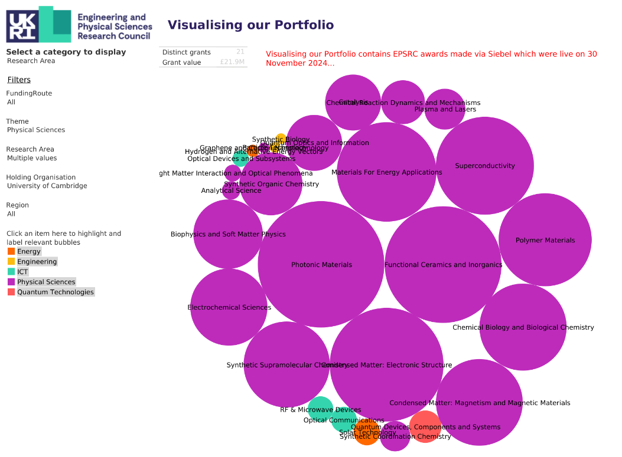

Flourish ‘Tree map’ of department groupings in Physical Sciences & Advanced Materials
https://public.flourish.studio/visualisation/22343402/
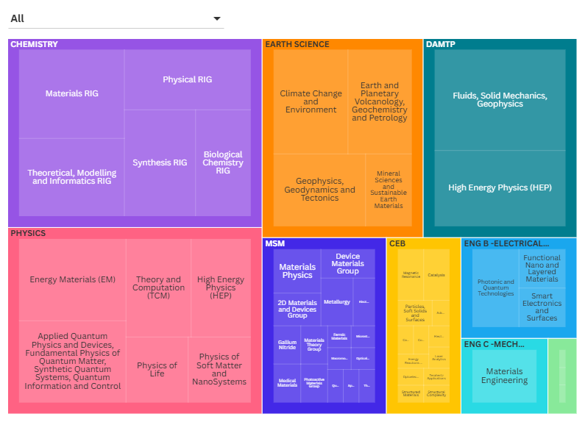
Research centres in Cambridge:
- iDMT - Innovation Centre in Digital Molecular Technologies
- CORDE -Collaborative R&D Environment
- Cambridge Centre for Gallium Nitride
- Cambridge Graphene Centre
- The Nanoscience Centre
- Centre for Physical Biology
- Centre of Molecular Materials for Photonics and Electronics

Quantum Technologies
https://www.ukri.org/what-we-do/browse-our-areas-of-investment-and-support/quantum-technologies-theme/
Summary
The EPSRC’s investment in quantum technologies via a dedicated theme, builds on long-standing underpinning investment in theoretical and quantum science. These strengths led to the establishment of the UK National Quantum Technologies (NQTP) Programme in 2014. The programme is now in its second phase and the government has invested over £1 billion in NQTP. The NQTP strategic intent document (PDF) sets out the strategy for the programme for the next 10 years.
Funding opportunities over the last 5 years have focussed on quantum technology fellowships, software enabled quantum computation, quantum technologies for positioning, navigation, and timing, quantum sensing for environmental sciences, quantum software and algorithms, quantum technologies for fundamental physics, quantum computing.
Visualising our Portfolio map of University of Cambridge Grant portfolio in Quantum Technologies by EPSRC Research Area
https://public.tableau.com/shared/BKDKY3QWJ
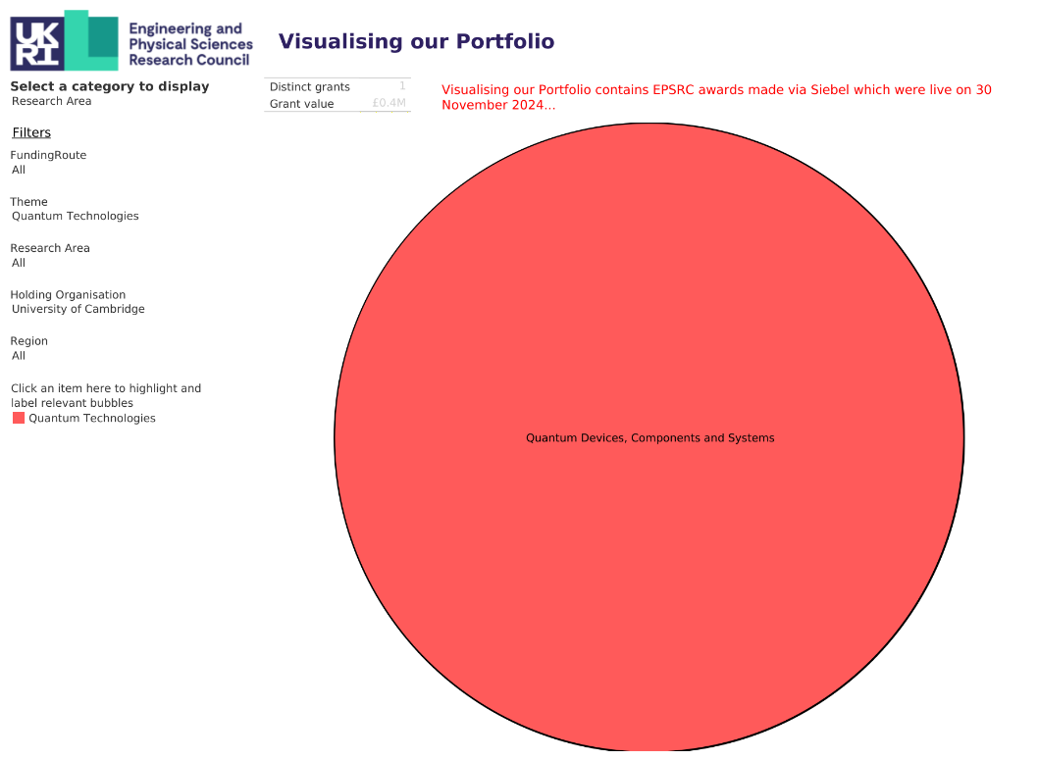

Flourish ‘Tree map’ of department groupings in Quantum Technologies
https://public.flourish.studio/visualisation/22323829/
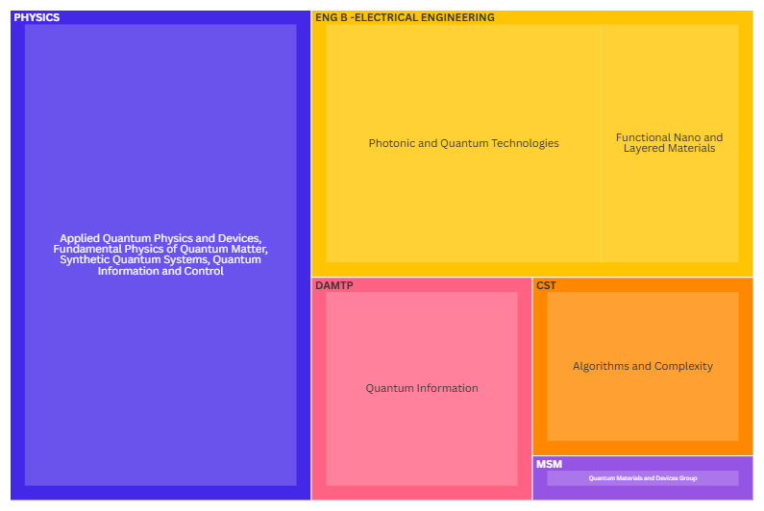
Research centres in Cambridge:
- Q-BIOMED
- Centre for Quantum Information and Foundations

Other Research Councils
NERC
Summary
NERC priorities have focussed on
- Digital Environment: Developing digital tools and computational models to better understand and manage environmental data.
- Environmental Sensors and Monitoring: Creating advanced sensors and monitoring systems to track environmental changes and impacts.
- Climate and Weather Modelling: Using computational techniques to improve climate and weather predictions.
- Sustainable Energy: Researching renewable energy sources and technologies to reduce environmental impact.
In Spring 2025, NERC will publish its first Forward Look for environmental science. Developed in collaboration with the community and stakeholders, NERC’s Forward Look will set out their research and innovation priorities and how they will support the underpinning capabilities needed to deliver environmental science over a ten-year horizon. NERC has identified three R&I priorities:
- Green Growth
- Environmental Security
- Responsible Innovation

Funding opportunities over the last 5 years have focussed on UK adaptation to climate change, data science for the environment, digital twinning for crisis resilience, sustainable industrial futures, clean energy transition in developing countries, systems approaches to net zero, sustainable critical minerals, modelling environmental responses to solar radiation management, modelling turbulent atmospheric processes, quantifying atmospheric processes in mountainous regions, ecological effects of floating offshore wind, marine sensor innovation, green economy, resilience of the UK food system, resilient UK coastal communities and seas, aviation’s non-CO2 impacts on the climate, environmental monitoring, sensing for defence and security, tools for automating image analysis for biodiversity monitoring, integrating finance and biodiversity, cosmogenic in situ 14C, rapid ocean changes, land use for net zero, biological influence on future ocean storage of carbon, derisking geological disposal of radioactive waste, quantum sensing for environmental sciences, quality of UK freshwaters, environmental response to hydrogen emissions, West Antarctic Ice Sheet’s response to a two degree increase, molecules to landscapes, policy impact of landuse, economics of biodiversity, health benefits of connecting with nature, clean air challenges, marine artificial structures, global partnerships (e.g. aquaculture systems in Southeast Asia, equitable nature-based climate resilience in Sub-Saharan Africa, understanding geohazard processes and their impacts across India), diversity in the environmental science community, public engagement with environmental science, discovery science (pushing the frontiers, exploring the frontiers of environmental science), training for environmental scientists.

Flourish ‘Tree map’ of department groupings relevant to NERC
https://public.flourish.studio/visualisation/22599748/
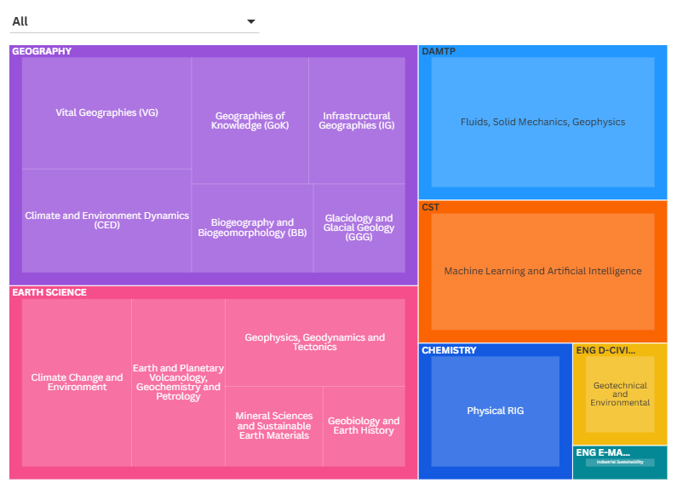

ESRC
Summary
ESRC currently have 5 priority research areas:
- Net Zero, environment, biodiversity and climate change
- digital society
- health and social care
- security, risk and resilience
- understanding behaviour
Funding opportunities over the last 5 years have focussed on economic productivity, economic (in)activity, policymaking, urban transition, energy transitions, systems approaches to net zero, adaptation to climate change, green economy, economics of biodiversity, sustainable management of marine resources, environmental social science, place based approaches to sustainable living, climate resilience, sustainable cities, levelling up, subthreshold conflict, community connectedness, democracy, governance systems, governance and trust, behavioural research, behavioural science for security and defence, population health, inclusive ageing, care sector labour force shortages, adolescent mental health and wellbeing, enhancing wellbeing for the future, longitudinal cohort studies, health inequalities, UK food systems, inequalities in food system, citizen science for food standards, healthy sustainable diets, crime and justice, modern slavery, forensic science, policing, teaching, learning and uses of technology in UK schools, protecting citizens online, working lives and power in the workplace, recovery, renewal and resilience in a post-pandemic world, digital economy, justice and data, metascience, secondary data analyses, scaled production and sharing of synthetic data, future internet, responsible and trustworthy AI, data services for the future, digital footprint data.
Flourish ‘Tree map’ of department groupings relevant to ESRC
https://public.flourish.studio/visualisation/22614176/
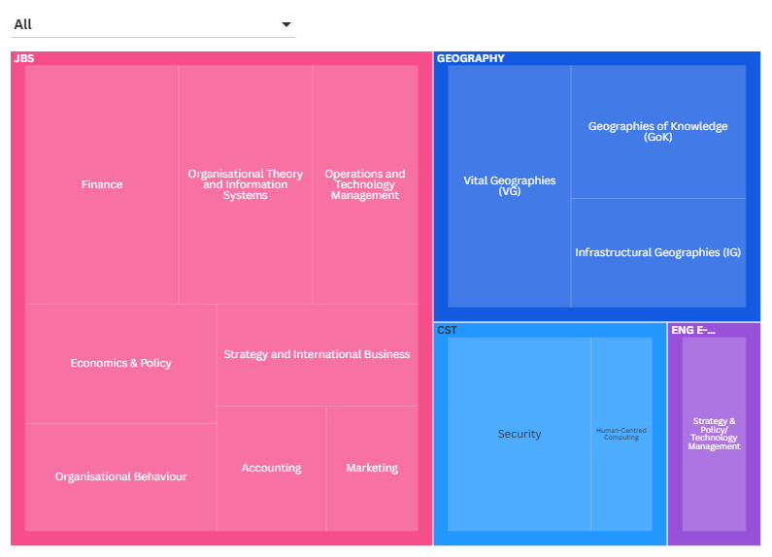

STFC
Summary
Science and Technology Facilities Council (STFC) funds research in these core areas:
- astronomy, solar and planetary science
- particle physics
- particle astrophysics
- nuclear physics
- accelerator science
- computational science
- quantum technologies

Funding opportunities over the last 5 years have focussed on Particle physics experiments, particle physics theory, astronomy solar and planetary studies, astronomy observation and theory, collaborative computational communities, rocketry, quantum technologies for fundamental physics, quantum for science, gravitational waves, future underground dark matter science experiments, public engagement, solar and planetary, resource for GridPP7 operations, nuclear physics, UK Square Kilometre Array (SKA) Regional Centre, facility access, STFC-Bioscience facility access, security and environment, CLASP energy and healthcare, allocation of telescope time, research software engineering.

Flourish ‘Tree map’ of department groupings relevant to STFC
https://public.flourish.studio/visualisation/22936214/
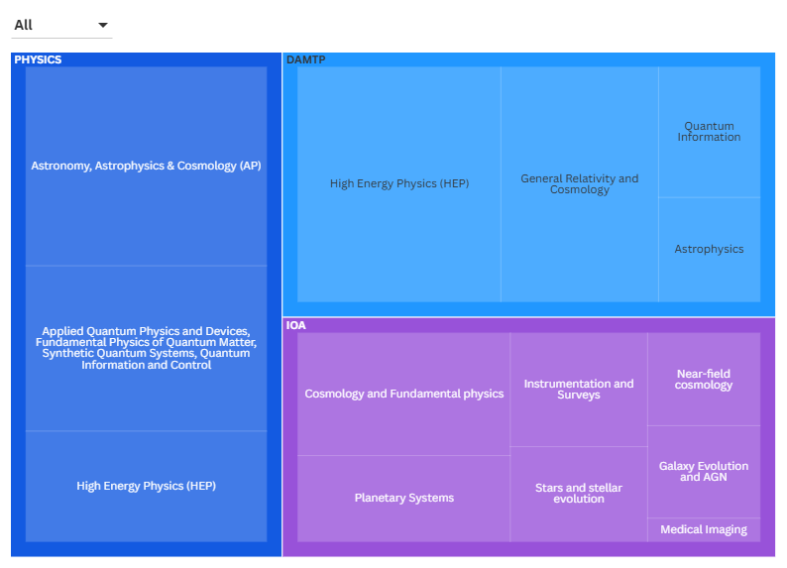

BBSRC
Summary
BBSRC’s priorities fall under bioscience discovery and strategic challenges
Priorities for ‘Advancing the frontiers of bioscience discovery’ are:
- understanding the rules of life
- transformative technologies

Priorities for ‘Tackling strategic challenges’ are:
- bioscience for sustainable agriculture and food
- bioscience for renewable resources and clean growth
- bioscience for an integrated understanding of health

Funding opportunities over the last 5 years have focussed on engineering biology, AI and data in the biosciences, bioinformatics and biological resources, antimicrobial resistance, ecology and evolution of infectious diseases, veterinary vaccine technology platforms, in vitro models/non-animal technologies, gut-immunology-brain axis, resource-efficient or bio-based materials and manufacturing, bioeconomy/green economy, diet and health, sustainable aquaculture, resilient food systems, future-proofing plants to a changing climate, alternative proteins, farmed animal diseases and health/endemic livestock diseases, protected and controlled environment horticulture, low-emission food production systems, agricultural soils, ageing, cognitive computational neuroscience, vector borne diseases, environmental solutions to zoonoses, synthetic cells or genomes, bioeconomy for technology-relevant metals and textiles, engineering biology for chemical production, molecules to landscapes, sensing and imaging, international partnerships.

Flourish ‘Tree map’ of department groupings relevant to BBSRC
https://public.flourish.studio/visualisation/22936689/
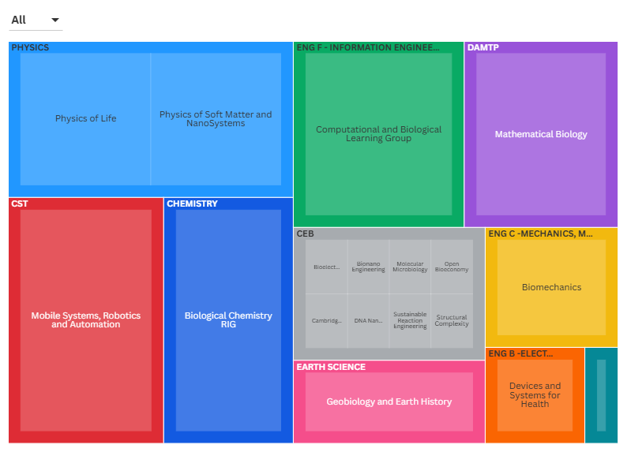

MRC
Summary
MRC
MRC’s five research boards have strategic priorities that help guide the research they invest in. Their research boards are:
- applied global health research
- infections and immunity
- molecular and cellular medicine
- neurosciences and mental health
- population and systems medicine

Funding opportunities over the last 5 years have focussed on advanced therapies, nucleic acid therapies, novel human in vitro models of complex disease, AI for health, enhancing healthspan, immune regulation, neuroimmunology, molecular mechanisms to inform cancer intervention, infectious diseases, multiple long term conditions, mental health, cancer immunotherapy, motor neurone disease, functional genomics, adolescent health, population health interventions, obesity, climate change and health, health inequalities, non communicable disease, brain injury, technological innovation for understanding cancers of unmet need, proactive vaccinology, eating disorders, rare diseases, neurodegenerative diseases and dementia, Total body PET, nutrition-responsiveness of the immune system, environmental sustainability in life sciences and medical practice, living and post-mortem human nervous tissue resources, pain, multimodal research across scales to understand human disease, hypersensitivities to food.
Flourish ‘Tree map’ of department groupings relevant to MRC
https://public.flourish.studio/visualisation/22946796/
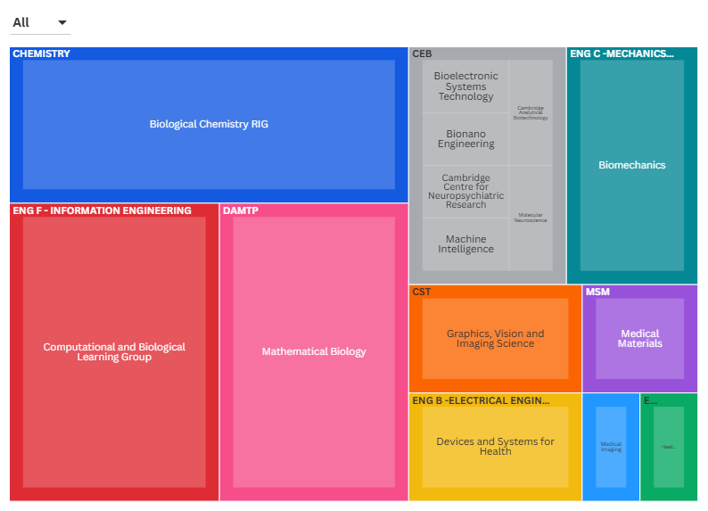

Information from UKRI webpages and research council delivery plans 2022-25
Topics of funding opportunities over the last 5 years were identified from the UKRI funder finder: Opportunities – UKRI
Data excludes Cambridge Zero and CISL, which do not contain standard academic staff.
Artificial intelligence and robotics is listed as a separate theme on EPSRC webpages but as this is predominately covered within other themes (notably ICT), we have not produced a separate map for this.
Although Physical Sciences and Advanced Materials are listed as separate themes on EPSRC webpages, they are governed by the same Strategic Advisory Team and are therefore we have grouped them together.

